Nashville City Cemetery

Why Visit Here?

# History Events

They’ve buried people from Veterans The cemetery has many different

to prison inmates, with their oldest known events from physical events to events

burial dating back to 1822. that help you learn more about the

cemetery while having fun as well.

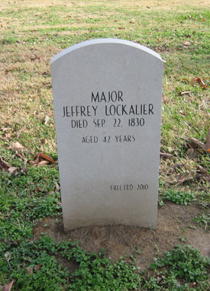 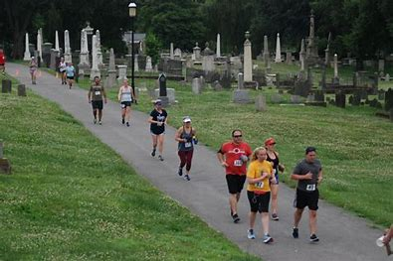

# Scenery

And lastly Nashville City Cemetery is home to a beautiful arboretum with many different trees and shrubs to admire while you’re walking.



 